**DAY-1 LAB PROGRAMS**

**NAME: ISHA SINGH**

**REG.NO:192210252**

**COURSE CODE: CSA1757**

**COURSE NAME: ARTIFICIAL INTELLIGENCE**

1. **8-PUZZLE PROBLEM**

**CODE:**

import heapq

def manhattan_distance(state, goal_state):

distance = 0

for i in range(3):

for j in range(3):

if state[i][j] != 0:

x, y = divmod(state[i][j] - 1, 3)

distance += abs(x - i) + abs(y - j)

return distance

def is_solvable(state):

flat_state = [num for row in state for num in row if num != 0]

inversions = 0

for i in range(len(flat_state)):

for j in range(i + 1, len(flat_state)):

if flat_state[i] > flat_state[j]:

inversions += 1

return inversions % 2 == 0

def get_neighbors(state):

neighbors = []

zero_row, zero_col = next((i, j) for i in range(3) for j in range(3) if state[i][j] == 0)

for move in [(-1, 0), (1, 0), (0, -1), (0, 1)]:

new_row, new_col = zero_row + move[0], zero_col + move[1]

if 0 <= new_row < 3 and 0 <= new_col < 3:

new_state = [row[:] for row in state]

new_state[zero_row][zero_col], new_state[new_row][new_col] = new_state[new_row][new_col], \

new_state[zero_row][zero_col]

neighbors.append(new_state)

return neighbors

def solve_8_puzzle(start_state, goal_state):

if not is_solvable(start_state):

print("The given puzzle is not solvable.")

return None

priority_queue = []

heapq.heappush(priority_queue, (manhattan_distance(start_state, goal_state), start_state, []))

visited = set()

visited.add(tuple(tuple(row) for row in start_state))

while priority_queue:

cost, current_state, path = heapq.heappop(priority_queue)

path = path + [current_state]

if current_state == goal_state:

return path

for neighbor in get_neighbors(current_state):

if tuple(tuple(row) for row in neighbor) not in visited:

heapq.heappush(priority_queue, (len(path) + manhattan_distance(neighbor, goal_state), neighbor, path))

visited.add(tuple(tuple(row) for row in neighbor))

return None

start_state = [

[1, 2, 3],

[4, 0, 6],

[7, 5, 8]

]

goal_state = [

[1, 2, 3],

[4, 5, 6],

[7, 8, 0]

]

solution_path = solve_8_puzzle(start_state, goal_state)

if solution_path:

print("Solution found!")

for state in solution_path:

print(state)

else:

print("No solution exists for the given start state.")

**OUTPUT:**

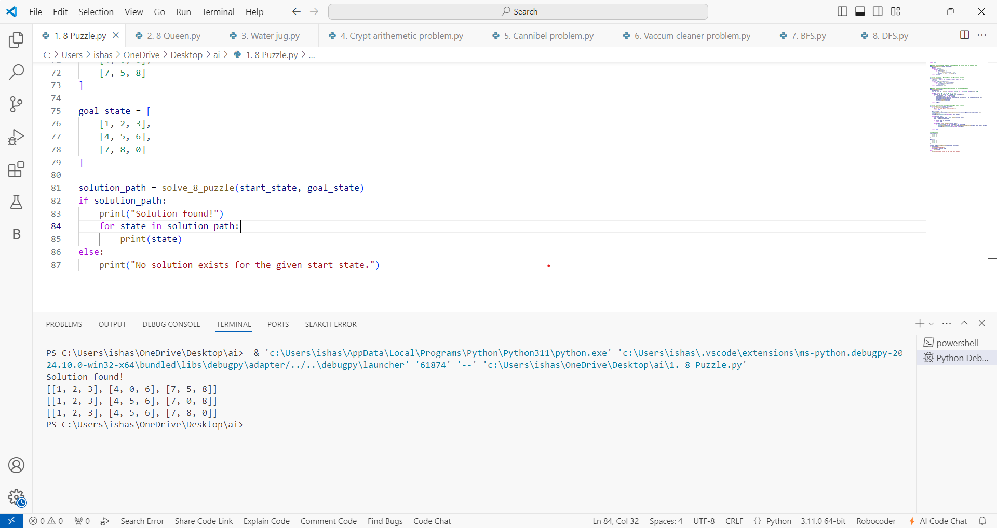

1. **8-QUEENS PROBLEM**

**CODE:**

def is_safe(board, row, col):

for i in range(col):

if board[row][i] == 1:

return False

for i, j in zip(range(row, -1, -1), range(col, -1, -1)):

if board[i][j] == 1:

return False

for i, j in zip(range(row, len(board), 1), range(col, -1, -1)):

if board[i][j] == 1:

return False

return True

def solve_queens(board, col):

if col >= len(board):

return True

for i in range(len(board)):

if is_safe(board, i, col):

board[i][col] = 1

if solve_queens(board, col + 1):

return True

board[i][col] = 0

return False

def print_board(board):

for row in board:

print(row)

def solve_8_queens():

board = [[0 for _ in range(8)] for _ in range(8)]

if not solve_queens(board, 0):

print("No solution found.")

return

print_board(board)

solve_8_queens()

**OUTPUT:**

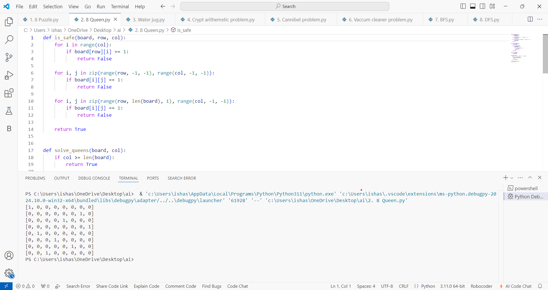

1. **WATER JUG PROBLEM**

**CODE:**

from collections import deque

def water_jug_bfs(jug1_capacity, jug2_capacity, target):

visited = set()

queue = deque()

queue.append((0, 0))

while queue:

current = queue.popleft()

jug1, jug2 = current

print(f"Jug1: {jug1}, Jug2: {jug2}")

if jug1 == target or jug2 == target:

print(f"Found solution: Jug1: {jug1}, Jug2: {jug2}")

return True

if current in visited:

continue

visited.add(current)

queue.append((jug1_capacity, jug2))

queue.append((jug1, jug2_capacity))

queue.append((0, jug2))

queue.append((jug1, 0))

pour_to_jug2 = min(jug1, jug2_capacity - jug2)

queue.append((jug1 - pour_to_jug2, jug2 + pour_to_jug2))

pour_to_jug1 = min(jug2, jug1_capacity - jug1)

queue.append((jug1 + pour_to_jug1, jug2 - pour_to_jug1))

print("No solution exists.")

return False

jug1_capacity = 4 # Capacity of Jug1

jug2_capacity = 3 # Capacity of Jug2

target_amount = 2 # The target amount of water

water_jug_bfs(jug1_capacity, jug2_capacity, target_amount)

**OUTPUT:**

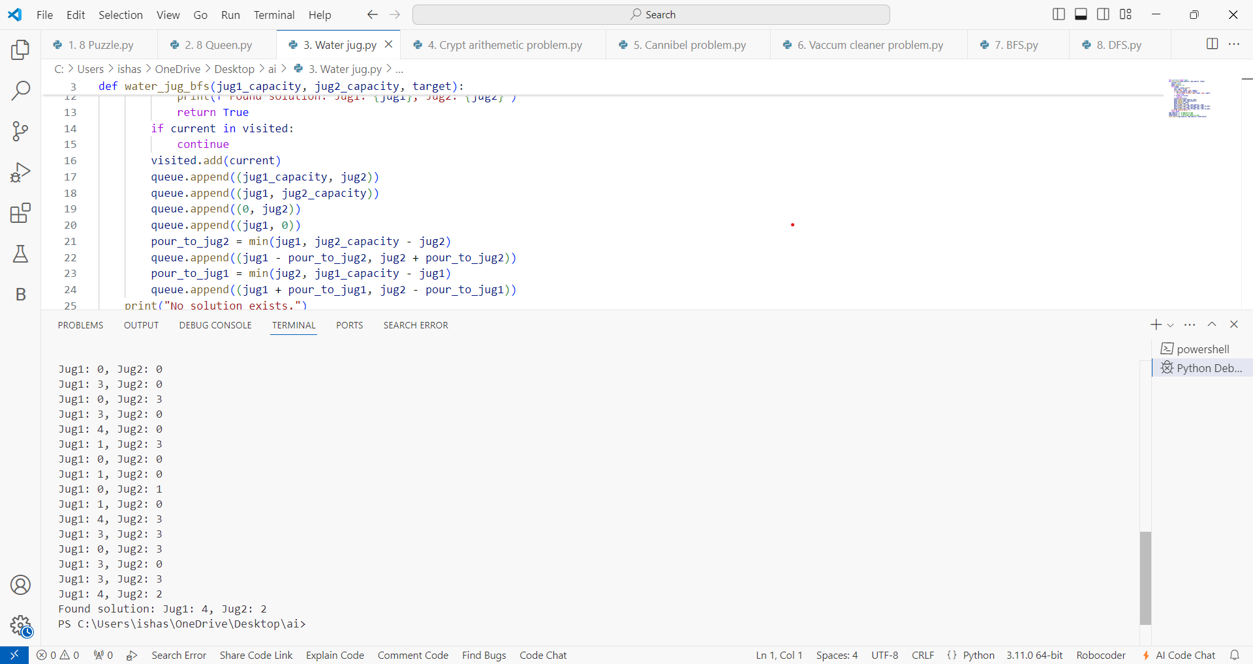

1. **CRIPT ARITHMETIC PROBLEM**

**CODE:**

from itertools import permutations

def is_solution(permutation):

s, e, n, d, m, o, r, y = permutation

send = s * 1000 + e * 100 + n * 10 + d

more = m * 1000 + o * 100 + r * 10 + e

money = m * 10000 + o * 1000 + n * 100 + e * 10 + y

return send + more == money

def solve_cryptarithmetic():

letters = 'SENDMORY'

for permutation in permutations(range(10), len(letters))

if permutation[letters.index('M')] == 0:

continue

if is_solution(permutation):

solution = dict(zip(letters, permutation))

print("Solution found:")

print(f"SEND + MORE = MONEY")

for letter in letters:

print(f"{letter} = {solution[letter]}")

send = solution['S'] * 1000 + solution['E'] * 100 + solution['N'] * 10 + solution['D']

more = solution['M'] * 1000 + solution['O'] * 100 + solution['R'] * 10 + solution['E']

money = solution['M'] * 10000 + solution['O'] * 1000 + solution['N'] * 100 + solution['E'] * 10 + solution['Y']

print(f"\nNumerical values:")

print(f"SEND = {send}")

print(f"MORE = {more}")

print(f"MONEY = {money}")

return solution

print("No solution found.")

return None

solve_cryptarithmetic()

**OUTPUT:**

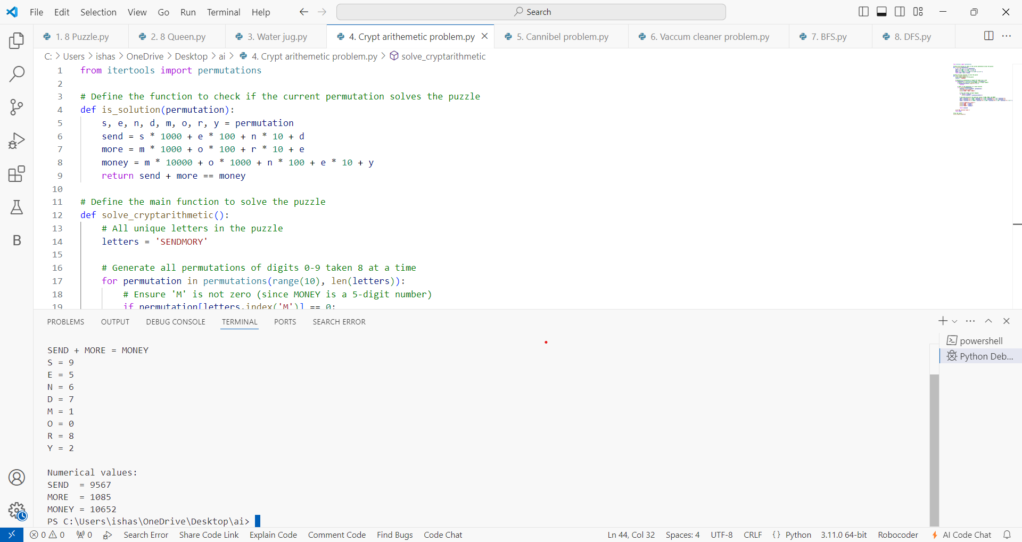

1. **MISSIONARIES AND CANNIBALS PROBLEM**

**CODE:**

from collections import deque

def is_valid_state(m, c):

if m < 0 or c < 0 or m > 3 or c > 3:

return False

if m > 0 and m < c:

return False

if (3 - m) > 0 and (3 - m) < (3 - c):

return False

return True

def successors(state):

m, c, b = state

moves = []

if b == 1:

possible_moves = [(-1, 0), (0, -1), (-2, 0), (0, -2), (-1, -1)]

else: possible_moves = [(1, 0), (0, 1), (2, 0), (0, 2), (1, 1)]

for dm, dc in possible_moves:

new_state = (m + dm, c + dc, 1 - b)

if is_valid_state(new_state[0], new_state[1]):

moves.append(new_state)

return moves

def bfs():

start_state = (3, 3, 1)

goal_state = (0, 0, 0)

visited = set()

queue = deque([(start_state, [])])

while queue:

state, path = queue.popleft()

if state == goal_state:

return path + [state]

if state not in visited:

visited.add(state)

for succ in successors(state):

queue.append((succ, path + [state]))

return None

solution = bfs()

if solution:

for i, state in enumerate(solution):

print(f"Step {i}: {state}")

else:

print("No solution found.")

**OUTPUT:**

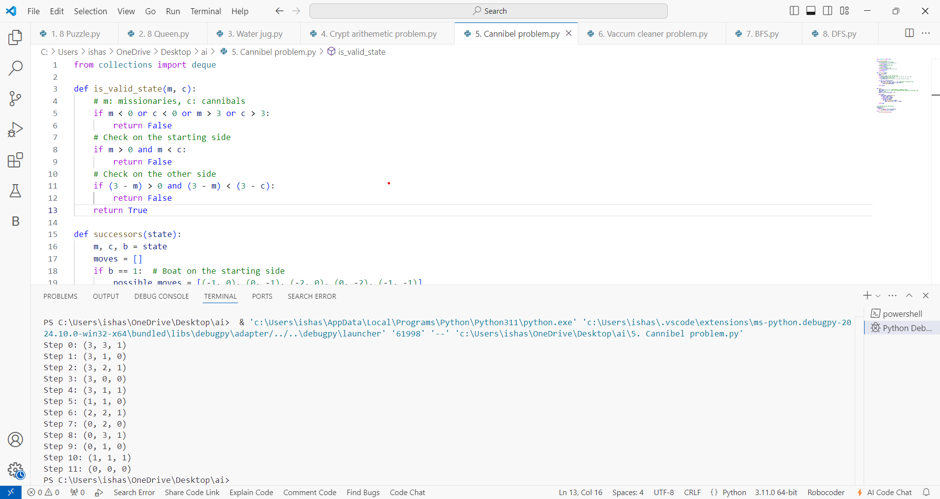

1. **VACCUM CLEANER AGENT PROBLEM**

**CODE:**

def clean_room(room):

return room.replace('D', '-')

def vacuum_cleaner_world(initial_room, initial_position):

current_room = initial_room

position = initial_position

print(f"Initial Room State: {current_room}")

while 'D' in current_room:

if current_room[position] == 'D':

current_room = clean_room(current_room)

print(f"Room Cleaned: {current_room}")

if position == 0:

position = 1

print("Moving to the right room.")

else:

position = 0

print("Moving to the left room.")

print("All rooms cleaned.")

initial_room1 = "D-"

initial_position1 = 0

vacuum_cleaner_world(initial_room1, initial_position1)

initial_room2 = "-D"

initial_position2 = 1

vacuum_cleaner_world(initial_room2, initial_position2)

**OUTPUT:**

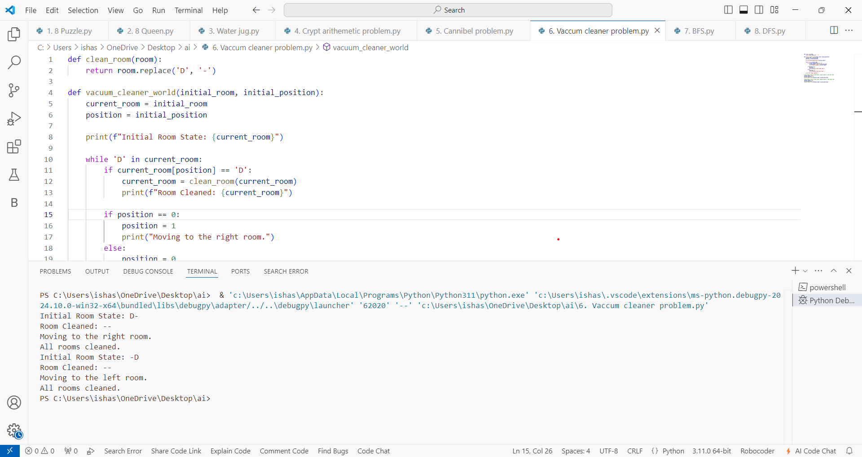

1. **BFS PROBLEM**

**CODE:**

from collections import deque

def bfs(graph, start):

visited = set()

queue = deque([start])

while queue:

node = queue.popleft()

if node not in visited:

visited.add(node)

print(node)

for neighbor in graph[node]:

if neighbor not in visited:

queue.append(neighbor)

graph = {

'A': ['B', 'C'],

'B': ['A', 'D'],

'C': ['A','E','F'],

'D': ['B'],

'E': ['C' ],

'F': [ 'C']

}

start_node = 'A'

bfs(graph, start_node)

**OUTPUT:**

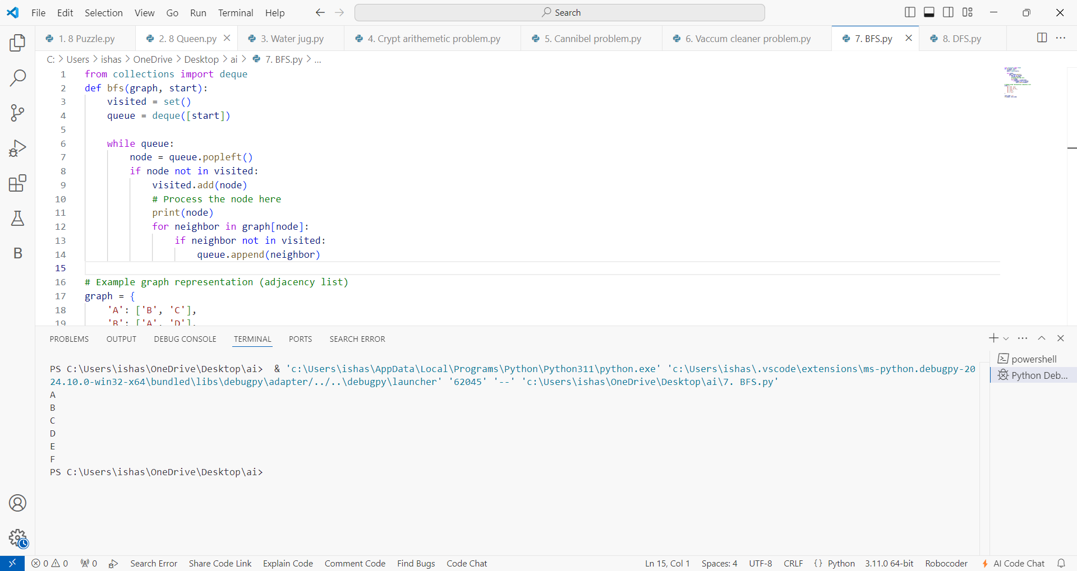

1. **DFS PROBLEM**

**CODE:**

def dfs(graph, start, visited=None):

if visited is None:

visited = set()

visited.add(start)

print(start)

for neighbor in graph[start]:

if neighbor not in visited:

dfs(graph, neighbor, visited)

graph = {

'A': ['B', 'C'],

'B': ['A', 'D', 'E'],

'C': ['A', 'F'],

'D': ['B'],

'E': ['B', 'F'],

'F': ['C', 'E']

}

start_node = 'A'

dfs(graph, start_node)

**OUTPUT:**

